Sioux City Community Schools –Free Microsoft Office for Students
Starting in December 2013 all 6th – 12th grade students in Sioux City Schools can download 5 free copies of Microsoft Office on any computer they wish through Microsoft’s new Student Advantage program. These copies of Microsoft Office are free and valid until the student is no longer attending Sioux City Schools. As part of the program, students can also download Microsoft Office mobile on iPhones, iPads, and Android smartphones. This program is only for students at this time NOT district staff members.
To install the latest version of Office
- Sign in to Office 365 by using your user ID.
- At the top right of the page, click Settings > Office 365 Settings.
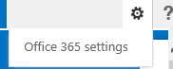
- Click Software.
- On the Office page, select a Language, and then click Install.
- To install Office Mobile, click on Phone & Tablet.
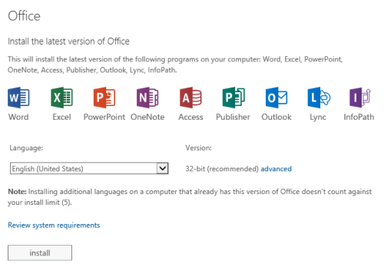
Instructions and more information can be found on Microsoft’s website using the following link:
http://office.microsoft.com/en-us/office365-suite-help/install-office-on-your-pc-or-mac-with-office-365-for-business-HA102822111.aspx

**** DISCLAIMER **** The Sioux City School District DOES NOT provide any technology support for home installation of Microsoft Office. Students (or parents) should be aware that installing office on home computers is done solely at their own risk.

