Printing Labels using Infinite Campus
May 22nd, 2014
Printing labels from canned reports in Infinite Campus are generated using Adobe Acrobat Reader. Adobe Reader is already installed on Sioux City Community School District computers.
YOU CAN’T PRINT DIRECTLY from Infinite Campus if you want labels to print properly on labels. This is because the default settings for Adobe Acrobat will result in misaligned labels.
Please follow these steps in order to PRINT labels so they are properly aligned.
Step 1: Generate the report within Infinite Campus. DO NOT USE PRINT BUTTON. You MUST download to your computer. Use the download button as shown below.
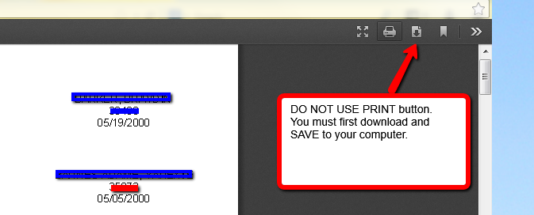

Step 2: After clicking the download button the following dialog box will appear. Click the radio button next to OPEN WITH Adobe Reader. Then click OK. See sample screen below.

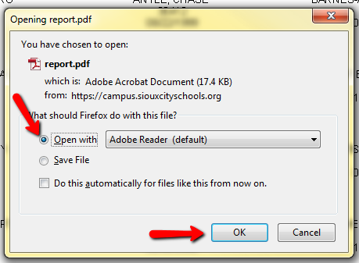
Step 4: Adobe Acrobat Reader will open. Click on the PRINTER icon as shown below.

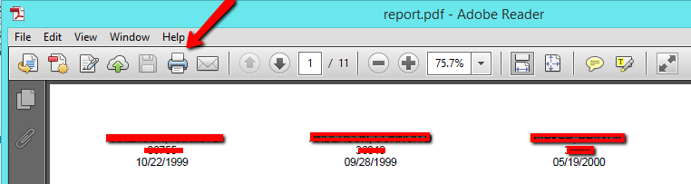

Step 5: From the PRINT dialog box in Adobe Reader YOU MUST change scaling to ACTUAL SIZE. Then click Print.
