Directions for Printing/Saving Seating Charts from Infinite Campus - THANKS MRS. LYMAN AND MRS. BURNIGHT
- OPEN WHATEVER SEATING CHART YOU WISH TO PRINT
- CLICK ON “REPORT OPTIONS” IN THE GRAY RECTANGULAR BOX
- 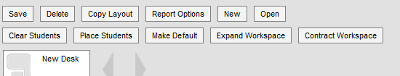
- FROM THE POP-UP WINDOW, CHOOSE PORTRAIT OR LANDSCAPE FROM THE DROP DOWN MENU, THEN
CLICK THE BOX FOR WHATEVER INFORMATION YOU WISH TO DISPLAY. (PICTURES AREN’T LOADED YET).

- ONCE YOU’VE CHOSEN YOUR OPTIONS, CLICK ON “GENERATE REPORT”

- FIND THE DOWNLOAD ICON ON THE TOP BAR OF THE DOCUMENT THAT OPENED. (3rd Icon with arrow pointing down)

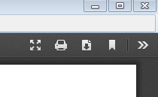
- IN THE WINDOW THAT POPS OPEN NEXT, CHOOSE “OPEN WITH ADOBE READER”
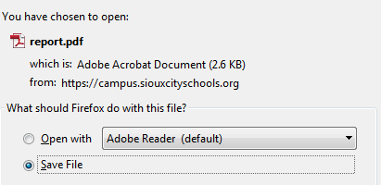

- FROM THE NEWLY PRODUCED pdf, CLICK FILE > SAVE AS >, AND STORE IT WHERE YOU WANT TO FIND IT. RENAME IT WITH THE PERIOD NAME
- 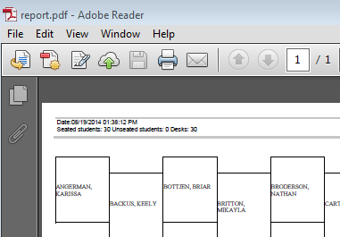

- ONCE IT IS SAVED, YOU CAN HIT PRINT FROM THE PDF FILE ICON. IT SHOULD PRINT TO YOUR DEFAULT PRINTER.

