Exporting Student Names from Infinite Campus to Excel
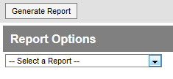
- In “Campus Instruction Beta”, select “Reports (Gradebook)”
- Choose “Select a report”
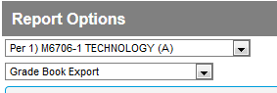
- From the drop down menu, choose “Gradebook Export”
- In the Choose the class you want to generate the report for.
- Click on the button labeled “Generate Report”.
- Choose “Open” with MS Excel…you will now have your class names listed in excel.

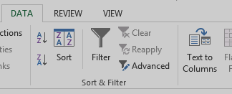
The directions below will review how to use excel to separate out the data (it all gets placed into the same column) into individual columns.
- Go to the “Data” tab on the ribbon bar and choose “text to columns”. This will start a three step process to clean up the data.
- Select “next” to move to the 2nd screen”
- In this screen check the following Tab, comma, space, and in other place a number sign….select “Finish” when complete.
- Your spreadsheet should show all data in separate columns. Simply delete or move a column in a manner that cps accepts and save.
