Preview a Report Card in Infinite Campus
On this document, you will be able to preview a report card individually by student. In Infinite Campus, you have to preview each report card by individual student, not by complete class. You will be able to see scores on the report card once you have posted scores from your gradebook to the report card.
- Log in to Infinite Campus and make sure you are on the Campus Tools side of Infinite Campus.
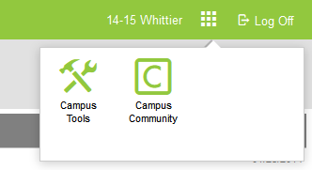
- Once you are on the Campus Tools side of Infinite Campus, along the left side, click the Search tab.
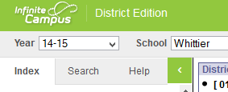
- After you click on the Search tab, where it says Search Students, type in the last name of the student you want to see the report card for. Click enter or click GO. Click on the student from your class you want to preview.
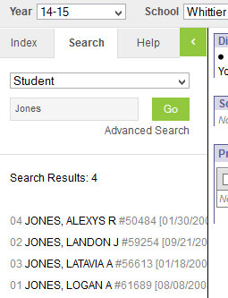
- Once you click on the student from your class, in the middle of the screen click the Grades tab.
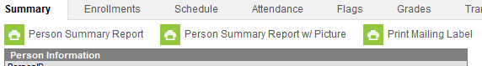
- Once you click on the Grades tab, click on the drop down arrow next to Choose a Report Card Format. Choose Elem report Card. The report card will generate in a PDF format.
