Post Grades to Standards-Based Report Card
- Open Grade Book
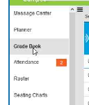

- Select class from Section menu
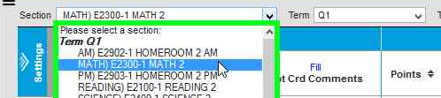

- Make sure that Term is set to Q1.
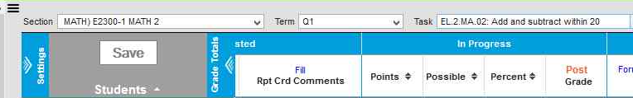

- Choose a standard (that was assessed) in Task dropdown menu
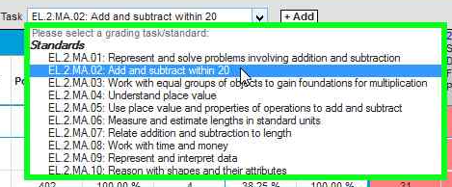

- Click on red Post Grade
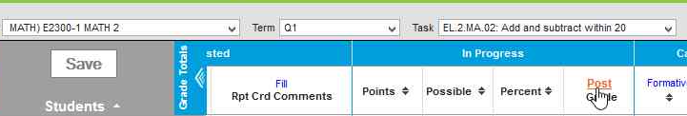

- Click OK
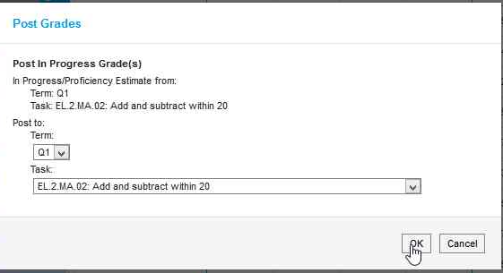

- Click OK
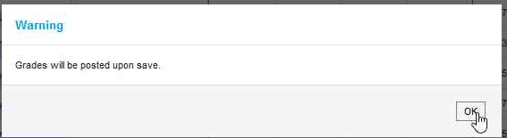

- Click Save
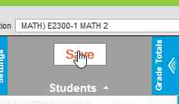
Your grades are now saved to the report card section of Infinite Campus Grade Book!
Repeat process for other sections taught this marking period.

