Post Grades to 7th and 8th Grade Report Cards

- Open Infinite Campus Grade book

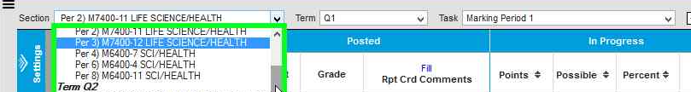
- Select a section from dropdown menu

- Check to make sure that Term is set to Q1
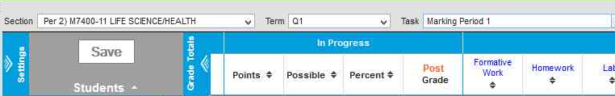

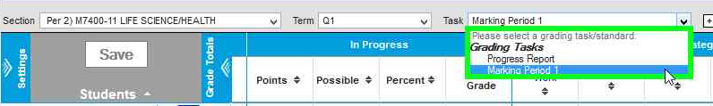
- Select Marking Period 1 in Task menu

- Click on red Post Grade
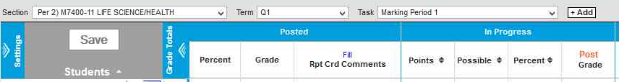

- Select correct Term; Select Marking Period 1 then click OK
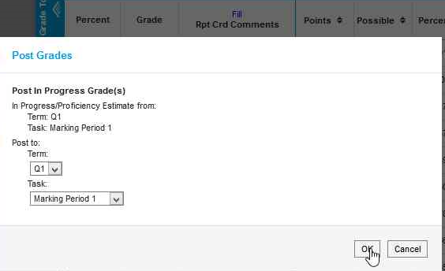

- Click OK

- Click Save
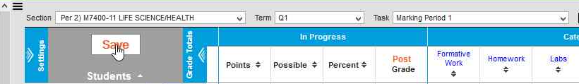

Grades for this section (or class) are now posted to the report card section of the Grade Book!
Repeat process for other sections.

