ADDING A SECONDARY TEACHER

Search>Course/Section and pick the course that you want to add the secondary teacher.
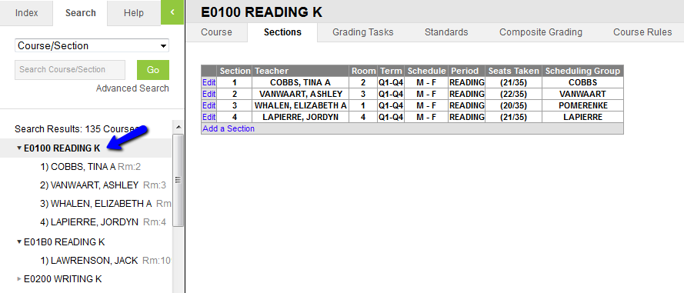
Click on Sections and then edit the section that you want to add the secondary teacher.
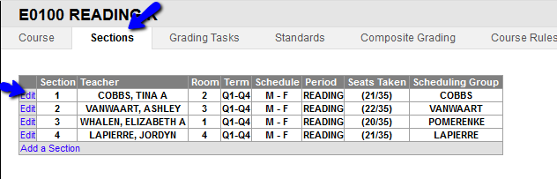

Click on Staff History
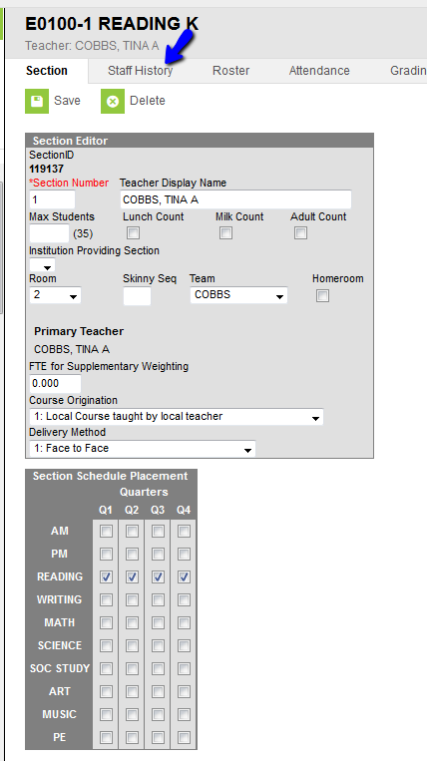

Click on New Teacher. Note, New Primary Teacher is to add the primary teacher. New Teacher is for adding a secondary teacher.
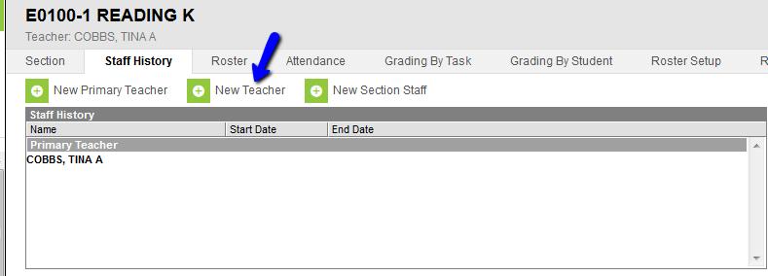
Once you click on New Teacher this display box shows up. Pick the secondary teacher and make sure the radial button is highlighted as shown. Then click SAVE.
