- Log in to Infinite Campus Grade Book using your District username and password. (Use Firefox)
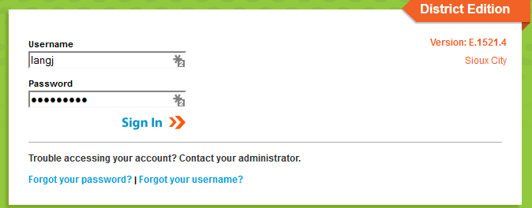

- Once you are logged in, make sure you are on the “gradebook side” of Infinite Campus. To make sure you are in the correct area, click the app switcher (9 little dots), and click Campus Instruction (Grade Book). Some of you already have your Grade Book set to automatically open on the Grade Book side, you are good to go.

- Once you are logged on to Infinite Campus Grade Book, make sure you are on the Grade Book side and click Grade Book along the left hand side of the screen.
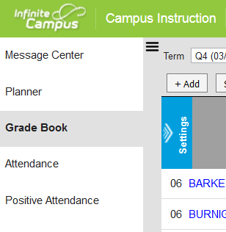
- At the top of the screen, choose the section you want to add this Assessment/Assignment in. The term and the task at this point does not matter.
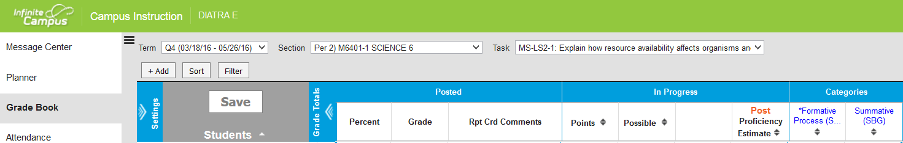

- Click Add located just above the student roster.
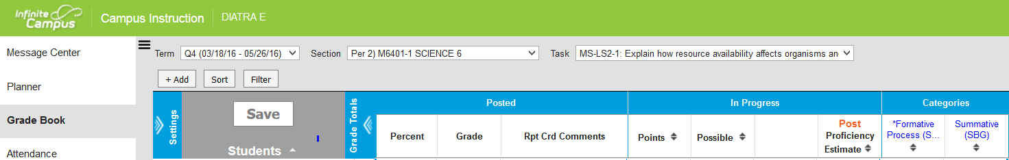

- A new box opens, Type in the name of the assessment/assignment, type in an Abbreviation, choose which sections(s) you wish to have this assessment/assignment, and choose a due date if you wish. (If you set up your assessments/ assignments in the Grade Book ahead of time, make sure the due dates you set fall in the quarter you want the item to appear on the report card.
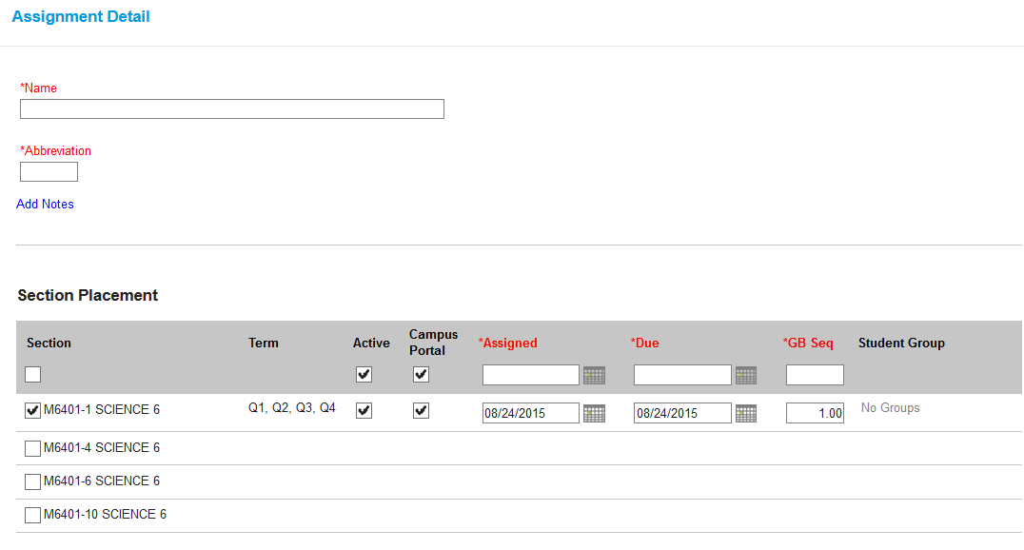
- Scroll down to the Grading Task Choose which category this item belongs, enter the Points value

Always remember to save your work as you enter grades.
There are multiple ways to achieve the same thing in Infinite Campus. Use the method that works best for you.

