- Log in to infinite Campus using your district username and password. (Use Firefox)
https://campus.siouxcityschools.org/campus/siouxcity.jsp
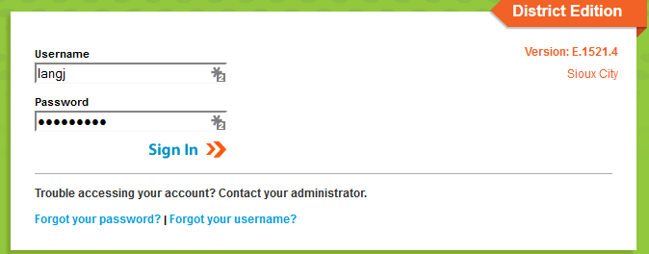

- Once you are logged in, make sure you are on the “gradebook side” of Infinite Campus. To make sure you are in the correct area, click the app switcher (9 little dots), and click Campus Instruction (Grade Book). Some of you already have your Grade Book set to automatically open on the Grade Book side, you are good to go.

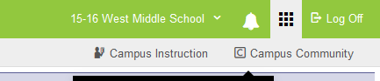
- Along the left hand side of the screen, click Grade Book.
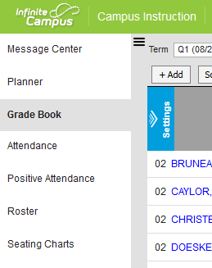

- Once you have clicked on Grade Book, on the top of the screen, in the section drop down, choose the section you want to add an assessment/assignment in. Then click add located right above the class roster.
- In the 6th grade Grade Book, we have the Standards Based Side of the Grade Book and the Traditional side of the Grade book. Here are a few things to know when adding assignments/assessments in this Grade Book.
- If you enter an assessment in the Summative (Quarter Grade) category, it also needs to be put in the Summative (SBG) category
- Entering scores on the Traditional Grade Book side (the 90% categories), doesn’t necessarily mean you can’t also put them in the Formative Process (SBG). You can. If what you are doing ties to a standard, but isn’t an assessment, you could put the score in the Traditional side of the Gradebook as well as the Formative Process (SBG) category.
- You can also enter items on the Traditional Grade Book side (90% categories) that don’t belong on the Formative Process (SBG) category. These items help the teaching/learning process, but aren’t necessarily directly tied to a standard.

#1- Recording a Summative Assessment
- Once you are logged on to Infinite Campus Grade Book, make sure you are on the Grade Book side and click Grade Book along the left hand side of the screen.
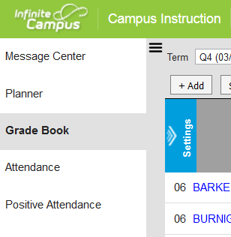
- At the top of the screen, choose the section you want to add this Assessment/Assignment in. The term and the task at this point does not matter.
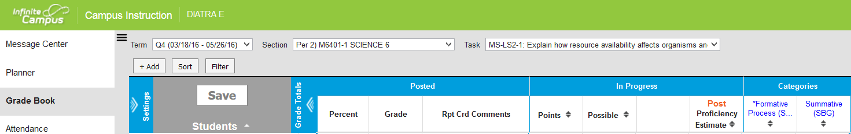

- Click Add located just above the student roster.
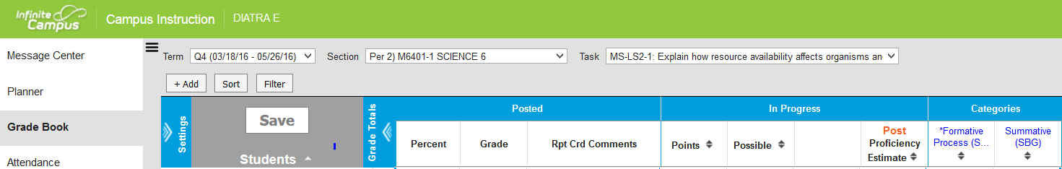

- A new box opens, Type in the name of the assessment/assignment, type in an Abbreviation, choose which sections(s) you wish to have this assessment/assignment, and choose a due date if you wish. (If you set up your assessments/ assignments in the Grade Book ahead of time, make sure the due dates you set fall in the quarter you want the item to appear on the report card.
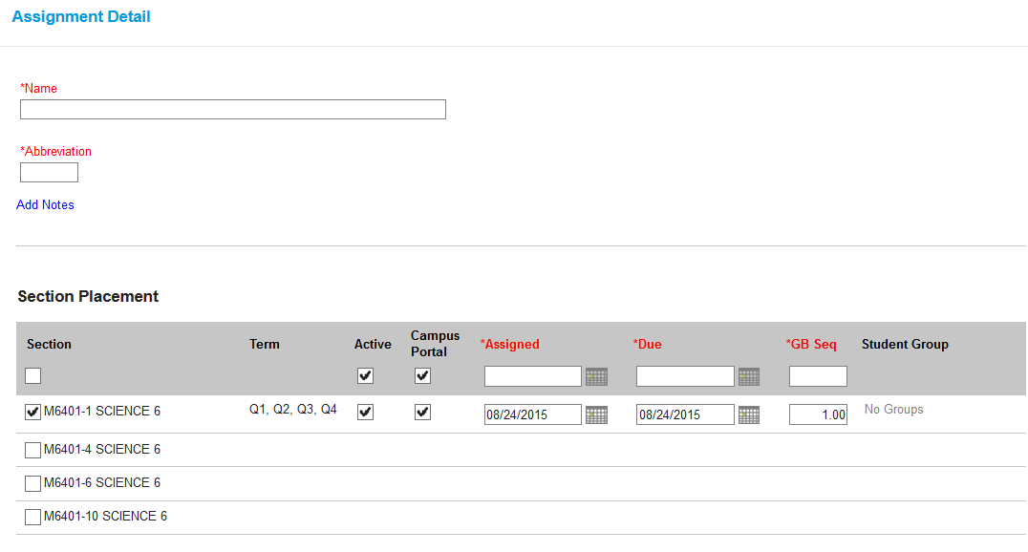

- On the same screen, scroll down and click on which standard(s) you are assessing. Click Summative (SBG), leave the Scoring Type as Rubric. Scroll down further and click Quarter Grade in the Grading Tasks area, click Summative (SBG), and enter a Point Value (Only do points on the traditional side of the Grade Book.
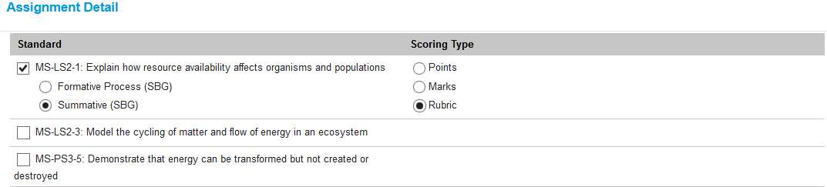
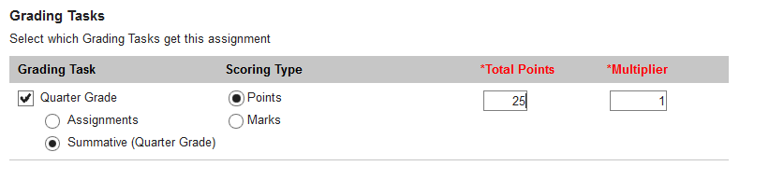
- Once you have completed those steps, you can now enter scores. Go back to your Grade Book.
- You should now have a column in your Grade Book that matches the Assessment/Assignment you just entered.
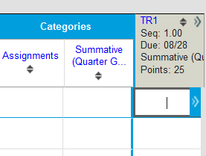
- There are a few different ways you can begin to enter scores. You can enter the SBG score and the Traditional score separately, or you can choose to use Multi Score and enter together on the same screen at the same time.
- To use multi score, click on the 2 little arrows that point to the right on the top of the Grade Book column you want to add scores in.

- Your Grade Book column will expand. On the right side, click Multi Score. A new box will open.
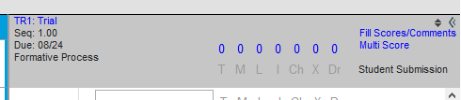

- In the multi score box, you will see student names across the left side and in the middle you will see the Standard (SBG) column on the left, and Traditional column right next to it and the area to enter scores below it. Once you have entered scores, Click Save On one screen in one area, you have completed this task.
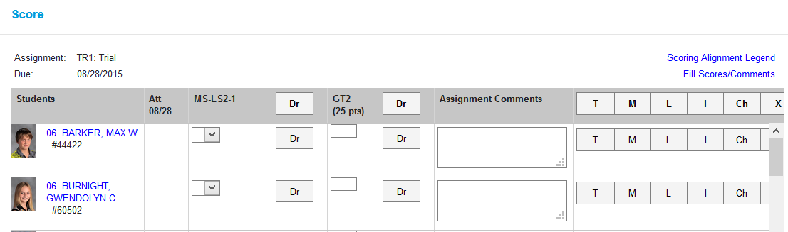

#2- Entering Assignments/Assessments on the Traditional side (90% categories) and also the Formative Process (SBG)
- Once you are logged on to Infinite Campus Grade Book, make sure you are on the Grade Book side and click Grade Book along the left hand side of the screen.
- At the top of the screen, choose the section you want to add this Assessment/Assignment in. The term and the task at this point does not matter.

- Click Add located just above the student roster.

- A new box opens, Type in the name of the assessment/assignment, type in an Abbreviation, choose which sections(s) you wish to have this assessment/assignment, and choose a due date if you wish. (If you set up your assessments/ assignments in the Grade Book ahead of time, make sure the due dates you set fall in the quarter you want the item to appear on the report card.
- On the same screen, scroll down choose which standard you are assessing. Click it. Choose Formative Process (SBG), Leave the Scoring Type as Rubric. Scroll down further and click Quarter Grade in the Grading Task area. Select which of your Categories this item belongs in. (one of your 90% categories). Enter the Total Points for this item. Click Save and return to your Grade Book, you have set up this Assessment or Assignment for score entry.
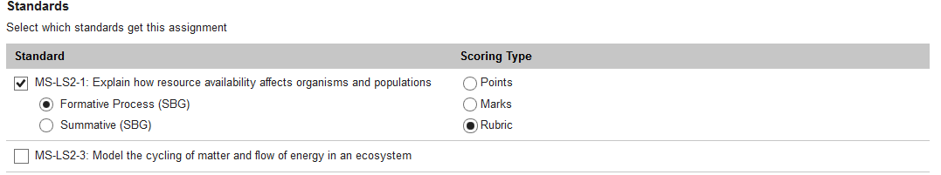
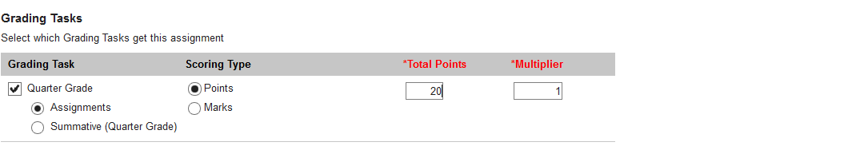
- Follow steps 8-11 in Example 1 to use Multi Score to enter scores.

#3- Entering Assignments as Traditional Grades only
- Once you are logged on to Infinite Campus Grade Book, make sure you are on the Grade Book side and click Grade Book along the left hand side of the screen.
- At the top of the screen, choose the section you want to add this Assessment/Assignment in. The term and the task at this point does not matter.

- Click Add located just above the student roster.

- A new box opens, Type in the name of the assessment/assignment, type in an Abbreviation, choose which sections(s) you wish to have this assessment/assignment, and choose a due date if you wish. (If you set up your assessments/ assignments in the Grade Book ahead of time, make sure the due dates you set fall in the quarter you want the item to appear on the report card.
- DO NOT CHOOSE ANY STANDARDS FOR THIS TYPE OF GRADE ENTRY, scroll down further and click on Quarter Grade in the Grading Task Area. Choose which category this item belongs, enter the Points value
- Click Save and go back to your Grade Book.
- In the Task box on the top of your screen, choose Quarter Grade located at the bottom of the drop down menu.
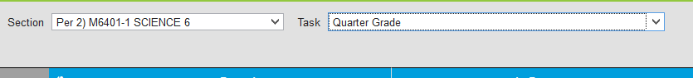
- You should now have a column in your Quarter Grade (Traditional Grade Book side) that matches what you just created.
- To enter scores, you can type in each box that corresponds to the correct student for that assignment, or you can use the multi score method that was discussed in the previous examples.

Always remember to save your work as you enter grades.
There are multiple ways to achieve the same thing in Infinite Campus. Use the method that works best for you.

