- Log in to infinite Campus using your district username and password. (Use Firefox)
https://campus.siouxcityschools.org/campus/siouxcity.jsp
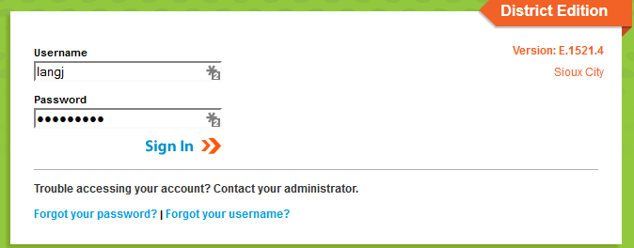

- Once you are logged in, make sure you are on the “gradebook side” of Infinite Campus. To make sure you are in the correct area, click the app switcher (9 little dots), and click Campus Instruction (Grade Book). Some of you already have your Grade Book set to automatically open on the Grade Book side, you are good to go.

- To start setting up your Grade Book, click Grade Book along the left side of the screen. Your Grade Book will open.
- On the top middle of the screen, in the section drop down box, start at the top and click on your first section (AM Homeroom)
- Once you have clicked on AM Homeroom, Click on the settings tab just above the first name on the roster
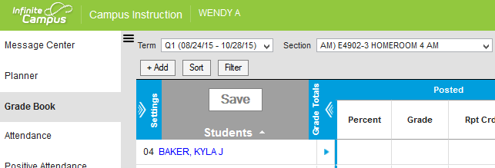
- After you click the settings tab, Click the canned comments button in the preferences before you go in and start creating categories.
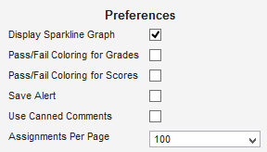
- Click on the Categories tab. In AM HOMEROOM ONLY, you will only create 1 category, Summative. In PM HOMEROOM, you will not create any categories. For all the other subject areas, you will create 2 categories, Summative and Formative Process.
- To set up your categories, choose a section, click on settings as explained above, click on categories.
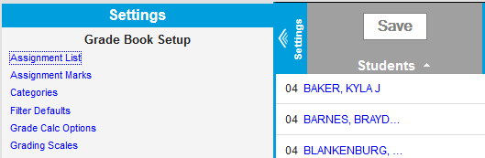
- When the new screen pops up, click Add. There are 4 things you need to do in order to set up a Summative category. 1. Name the category Summative, 2. Click on the Term box in the gray area (See picture below), 3. Click the Standards box in the gray area (See picture below), 4. Click Save
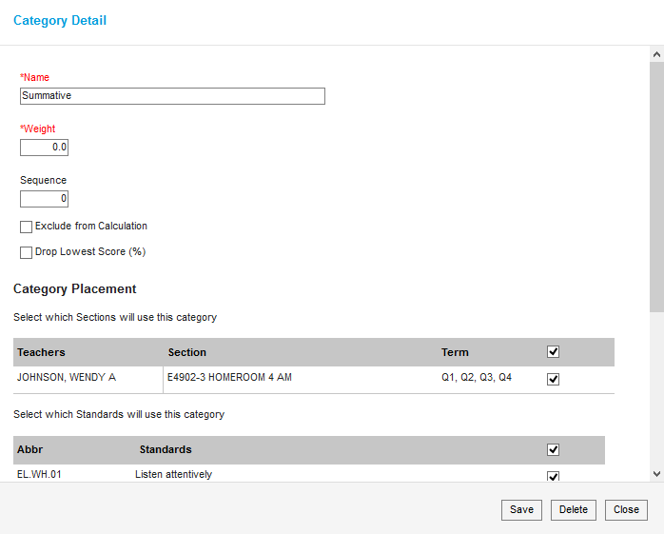

- For the rest of the subject areas, you will also need to create a Formative Process Category. There are 5 things you need to make this category. While you are still in the Categories area, click Add again. Here are the 5 things you need to do… 1. Name the category Formative Process, 2. Click Exclude from Calculation, 3. Click the Term box in the gray area (See picture below), 4. Click the Standards box in the gray area (See picture below), 5. Click Save
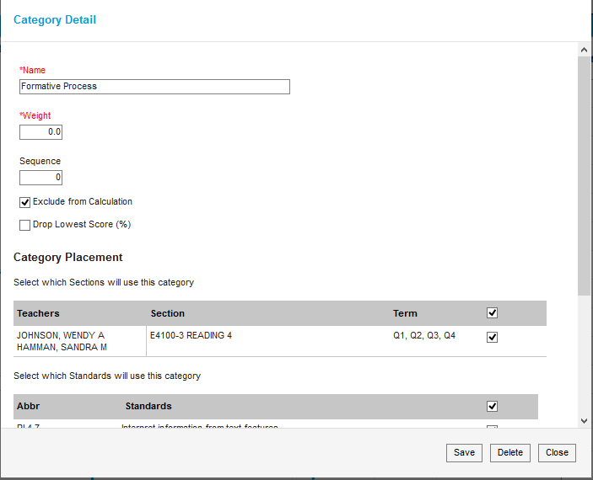
- In all sections except AM HOMEROOM (1 Category) and PM Homeroom (NO Categories), your category list should look like this when finished.
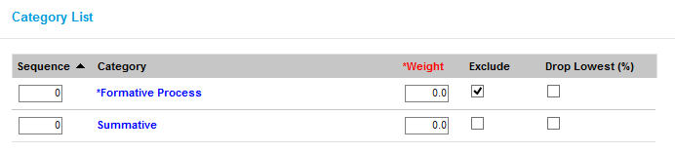
- Once you finish setting up the Categories in a specific section, before you move to a new section you need to set up the Grade Calc Options.

- In the settings area, click on Grade Calc Options, Click Continue
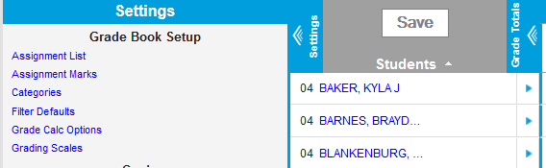

- In the box where it says Type, choose Proficiency Estimate. In the Method box, choose Highest Score. Click save. This applies to all standards for a specific subject area. You can now move on to a new subject area. Repeat the steps above.
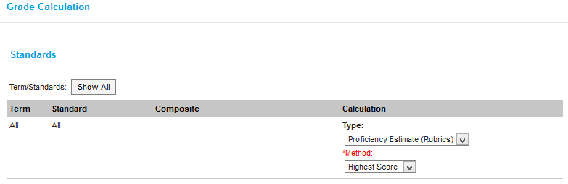

Once you have set up the 1 Summative Category for AM HOMEROOM, and 2 Categories (Summative and Formative Process) Categories for your other sections (No Categories in PM HOMEROOM), you are set and ready to begin entering assignments and assessments.

