- Log in to infinite Campus using your district username and password. (Use Firefox)
https://campus.siouxcityschools.org/campus/siouxcity.jsp
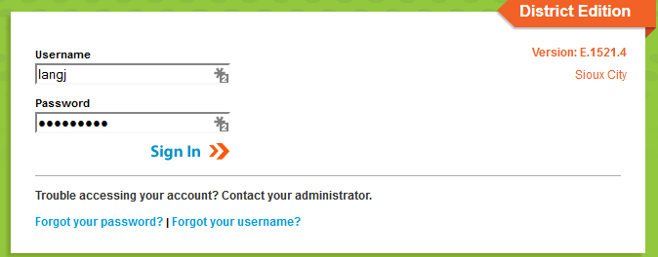

- Once you are logged in, make sure you are on the “Grade Book side” of Infinite Campus. To make sure you are in the correct area, click the app switcher (9 little dots), and click Campus Instruction (Grade Book). Some of you already have your Grade Book set to automatically open on the Grade Book side, you are good to go.

- To start setting up your Grade Book, click Grade Book along the left side of the screen. Your Grade Book will open.
- On the top middle of the screen, in the Section drop down box, start at the top and click on your first period that requires set up
- Once you have clicked on the period you want to start setting up , Click on the Settings tab just above the first name on the roster
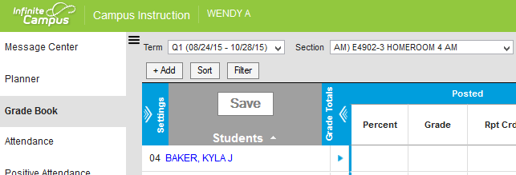
- After you click the Settings tab, Click the Use Canned Comments button in the preferences area before you go in and start creating categories.
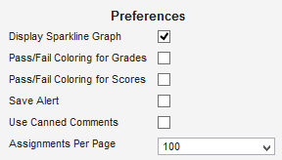

- Click on the Categories tab. Here you will create a minimum of 2 categories. Your categories that you will need are as follows-
      - Marking Period Exam This category MUST be named as it is typed to the left. This category has a value of 10%
      - Assignments (Quarter Grade) (Doesn’t need to be named this) 90% of final grade (This category can be broken up into other categories as long as the total value of all categories equals 90% of the final grade)
- To set up your categories, choose a section, click on Settings as explained above, click on Categories. Click Add
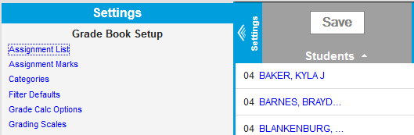

- (For my example, I am using a scale of 1-10, each number equivalent to 10% to assign weights to the categories for Traditional Grading)
The first category you set up for your traditional grading side of the Grade Book must be called Marking Period Exam (This must be named this way and have a value of 10%–) There are 5 things to do in order to set up this category. 1. Name the category Marking Period Exam 2. Give it a weight of 1 (I used a 10 point scale to determine weight) (1 out of 10 meaning this category is 10% of the final grade). 3. Click the Term box in the gray area (See picture below), 4. Scroll down and click the Grading Task box in the gray area, 5. Click save

- The next category that you set up is where you have some flexibility. On the previous step, we set up a category named Marking Period Exam. That category must be weighted at 10% of the final grade, leaving you with 90% left to set up categories that best fit how you run your classroom.
Here are some examples on how you can use the final 90% while setting up categories.
- If you want to go just by total points and lump everything except your exams together, create one new category, name it whatever you want and give it a weight of 9. (Why 9? Because your exam had a weight of 1 or 10%, leaving you 9 points or 90% left to create your gradebook.) Your Summative (Quarter Grade) category and your new category you just created would equal a value of 10 points or 100%. If you go by total points accounting for 90% of your grade, your Grade Book should look something like this. Notice the weights of the categories add up to 10, or 100% of a grade for a student.
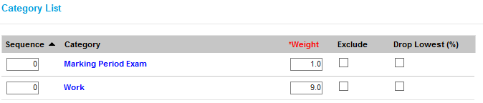

- If you want to break up the 90% or 9 points in to different categories, you may do so. If you want homework to be 20% of the final grade, create a category titled homework, give it a weight of 2 (which equals 20%), create a category titles labs, give it a weight of 2 (which equals 20%), create a project category give it a weight of 3 (Which equals 30%). So far in this example I have the following categories (If you want to create multiple categories for break up the final 90% of your Grade Book, follow step 12 for how to create these categories with different names and weight values)
      - Marking Period Exam- weight of 1 or 10% of final grade
      - Homework- weight of 2 of 20% of final grade
      - Labs- weight of 2 or 20% of final grade
      - Project- weight of 3 or 30%of final grade
That leaves me at 80% of my gradebook set up and decided, I have 20% left to create. My final category could be titled Classroom Group Work, give it a weight of 2 (Which equals 20%). I have now used all 10 points or 100% to create my Grade Book. Your categories should look like this if you chose this method….

- You have now set up your categories for that class period. The next step is to set up Grade Calc Options
- While still in the Settings Tab, Click Grade Calc Options. Click Continue

- When the Grade Calc box opens, do the following-

- In the Type box choose In Progress Grade
- where it says grading scale choose SCCSD Grading Scale
- and click the box next to Weight Categories
- Click Save
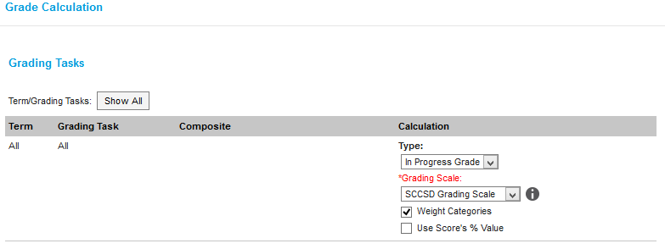
You have now completed your Grade Book set up for your first class. Move to your next section and repeat the process. ( Please note, those of you that teach the exact same class but have multiple sections, depending on how things were set up in the back ground, you will be able to push these set ups to multiple sections all at the same time. You will know if that is possible when you set up your first category, when you click the Term box, multiple sections will have check marks by it.)

