- Log in to infinite Campus using your district username and password. (Use Firefox)
https://campus.siouxcityschools.org/campus/siouxcity.jsp
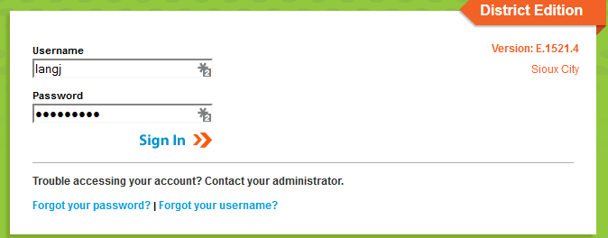

- Once you are logged in, make sure you are on the “Grade Book side” of Infinite Campus. To make sure you are in the correct area, click the app switcher (9 little dots), and click Campus Instruction (Grade Book). Some of you already have your Grade Book set to automatically open on the Grade Book side, you are good to go.

- To start setting up your Grade Book, click Grade Book along the left side of the screen. Your Grade Book will open.
- On the top middle of the screen, in the Section drop down box, start at the top and click on your first period that requires standards
- Once you have clicked on the period you want to start setting up , Click on the Settings tab just above the first name on the roster
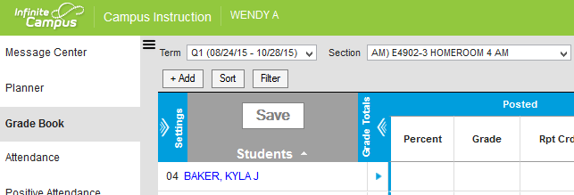
- After you click the settings tab, Click the Use Canned Comments button in the preferences area before you go in and start creating categories.
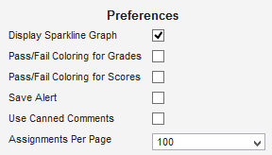

- Click on the Categories tab. Here you will create a minimum of 4 categories. Your categories that you will need are as follows- (Numbers 1-3 must be named as listed below) category 4 can be broken up as you see fit. If you want to do total points, label Number 4 whatever you want and make sure it is set as 90% of the final grade. If you want to break category 4 up in to different pieces like lab, homework, project etc…. you can, just add more categories and make sure all your extra categories add up to 90% Categories 1 and 2 are for Standards Based Grading, Categories 3 and 4 (or more) are for traditional side of your Grade Book)
      - Summative (SBG)
      - Formative Process (SBG)
      - Summative (Quarter Grade) This must be set as 10% of final grade (Used to be labeled Marking Period Exam)
      - Assignments (Quarter Grade) 90% of final grade (This category can be broken up into other categories as long as the total value of all categories equals 90% of the final grade)
- To set up your categories, choose a section, click on settings as explained above, click on Categories.
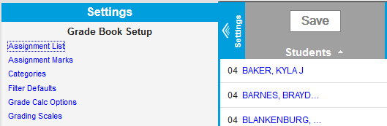
- The first category that needs set up is the Summative (SBG) category. Once you have clicked Categories in the settings area, click Add. There are 4 things you need to do to set up this category. 1. Name the category Summative (SBG), 2. Click the Term box in the gray area (See picture below, 3. Click the Standards box in the gray area (See picture below), 4. Click Save
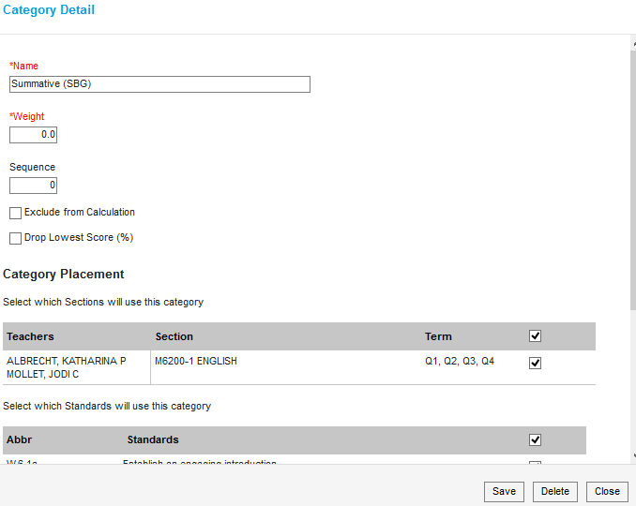
- The next category that needs set up is Formative Process (SBG) category. While still in the categories section, once again click Add. There are 5 things you need to do to create this category. 1. Name the category Formative Process (SBG), 2. Click the box by Exclude from Calculations, 3. Click the Term box in the gray area (See picture below), 4. Click the Standards box in the gray area (See picture below), 5. Click Save *When you look at the category list when finished, there will be an asterisk next to Formative Process (SBG)
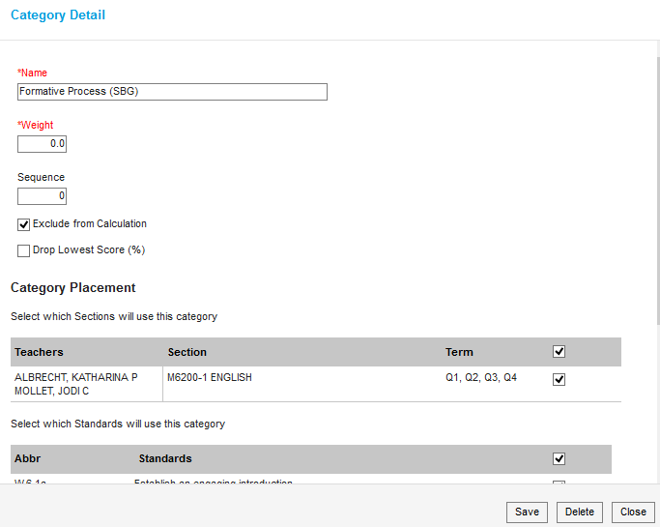
- Steps 8, 9 and 10 sets up the Standards Based Grading (SBG) side of your Grade Book.
- Now we will set up the Traditional Grading side of your Grade Book. While still in the Categories section, click Add.
- (For my example, I am using a scale of 1-10, each number equivalent to 10% to assign weights to the categories for Traditional Grading)
The first category you set up for your traditional grading side of the Grade Book must be called Summative (Quarter Grade) This must be named this way and have a value of 10%– This used to be labeled “Marking Period Exam” There are 5 things to do in order to set up this category. 1. Name the category Summative (Quarter Grade), 2. Give it a weight of 1 (I used a 10 point scale to determine weight) (1 out of 10 meaning this category is 10% of the final grade). 3. Click the Term box in the gray area (See picture below), 4. Scroll down and click the Grading Task box in the gray area, (DO NOT CLICK THE STANDARDS BOX FOR TRADITIONAL GARDEBOOK SET UP) 5. Click save

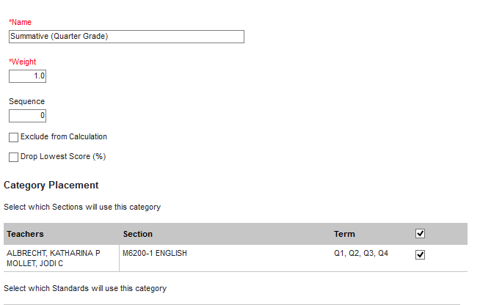
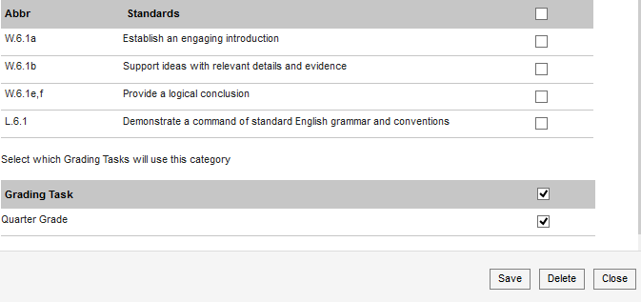
Do NOT Click this box on this step
- The next category that you set up is where you have some flexibility. On the previous step, we set up a category named Summative (Quarter Grade). That category must be weighted at 10% of the final grade, leaving you with 90% left to set up categories that best fit how you run your classroom.
Here are some examples on how you can use the final 90% while setting up categories.
- If you want to go just by total points and lump everything except your exams together, create one new category, name it whatever you want and give it a weight of 9. (Why 9? Because your exam had a weight of 1 or 10%, leaving you 9 points or 90% left to create your Grade Book.) Your Summative (Quarter Grade) category and your new category you just created would equal a value of 10 points or 100%. If you go by total points accounting for 90% of your grade, your Grade Book should look something like this.
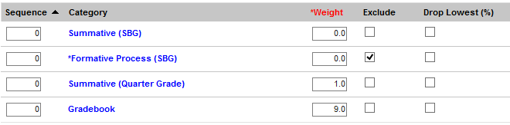

- If you want to break up the 90% or 9 points in to different categories, you may do so. If you want homework to be 20% of the final grade, create a category titled homework, give it a weight of 2 (which equals 20%), create a category titles labs, give it a weight of 2 (which equals 20%), create a project category give it a weight of 3 (Which equals 30%). So far in this example I have the following categories (If you want to create multiple categories for break up the final 90% of your gradebook, follow step 12 for how to create these categories with different names and weight values)
      - Summative (Quarter Grade)- weight of 1 or 10% of final grade
      - Homework- weight of 2 of 20% of final grade
      - Labs- weight of 2 or 20% of final grade
      - Project- weight of 3 or 30%of final grade
That leaves me at 80% of my Grade Book set up and decided, I have 20% left to create. My final category could be titled Classroom Group Work, give it a weight of 2 (Which equals 20%). I have now used all 10 points or 100% to create my Grade Book. Your categories should look like this if you chose this method…. (Notice the top 2 are SBG. The bottom 5 are traditional grading set up with weights that equal 10 points or a value of 100% of total grade)
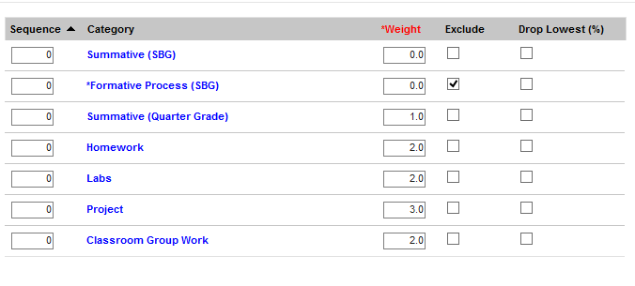
- You have now set up your categories for that class period. The next step is to set up Grade Calc Options
- While still in the Settings Tab, Click Grade Calc Options. Click Continue

- When the Grade Calc box opens, you will see 2 parts. The top is to set up the SBG side of your gradebook, the bottom is to set up the Traditional Side of your Grade Book.

- On the top, or the SBG section, in the type box, choose Proficiency Estimate (Rubrics), in the Method box, choose Highest Score
- On the bottom, or Traditional Grading section, in the Type box choose In Progress Grade, where it says grading scale choose SCCSD Grading Scale, and click the box next to Weight Categories, Click Save
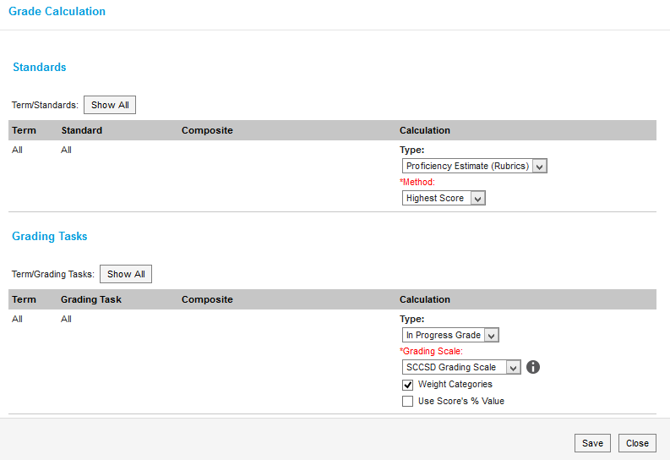
You have now completed your Grade Book set up for your first class. Move to your next section and repeat the process. ( Please note, those of you that teach the exact same class but have multiple sections, depending on how things were set up in the back ground, you will be able to push these set ups to multiple sections all at the same time. You will know if that is possible when you set up your first category, when you click the Term box, multiple sections will have check marks by it.)

