Adding Canned Comments for report Cards in Infinite Campus
On this document, you will be able to set up your grade book to enter Canned Comments and be able to assign Canned Comments to both whole class and individual students. There are many ways to be able to enter Canned Comments. Here are a couple ways to do this. If you have found a different way that works for you, please do it..
- Log in to Infinite Campus
- Make sure you are on the “Gradebook side” of Infinite Campus.
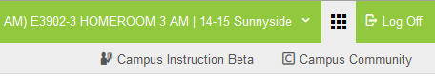
- In order to be able to able to assign a Canned Comment to an individual student or whole class, you need to make sure the Canned Comment check box is checked for every section you wish to be able to assign a comment.
- Click on Grade Book along the left side of Infinite Campus.
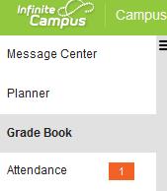
- Choose any section in the gradebook that you wish to add Canned Comments for students. Then click the settings tab.
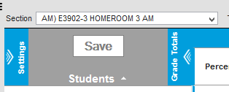
- In the settings area, make sure a check mark is in the Use Canned Comments check box.
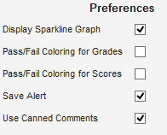
- Repeat steps 5 and 6 for any Section you want to be able to add Canned Comments to.

- Here is where you have a couple options in where you put the comments.
  - Option 1- You can insert a comment in specific subjects area, just place the comment as part of the last standard listed in that subject area so all comments are listed after the standards.
  - Option 2- In AM Homeroom, the very last standard says “Teacher Comments”. The purpose of this last standard isn’t for you to enter a score of 1,2,3,4, but for you to be able to put all comments for any subject area or standard in one spot so parents/guardians can easily find the comments.
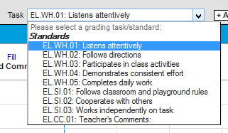
- Once the setup is complete, you will begin to enter Canned Comments by going to Post Grades.
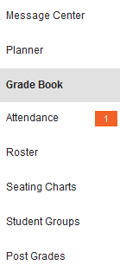
- In Post Grades, click on the section you want to add a Canned Comment. Your class roster should appear. If not, where it says Term, choose the correct Quarter, and where it says Task, choose the standard you wish to add a Canned Comment for.
- Once you have chosen the task, click Fill Percent, Grade, Comment
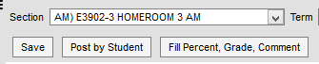
- Once you click Fill Percent, Grade, Comment, a new box opens. To give a common Canned Comment to all students, put a check box in the box next to Comment and put a check in the check box next to the Comment(s) you wish to give to all students in your class. Click fill at the bottom of the screen.
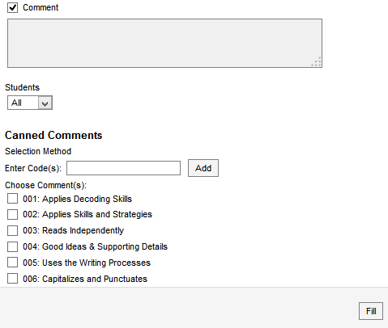
- After you click fill, it takes you back to the Post Grades screen. All your students now have the Canned Comment that you assigned. Click save towards the top right before you do anything else.
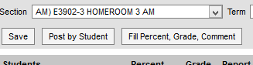
- If you wish to give additional Canned Comments to individual kids, in Post Grades click on the section you want to add a Canned Comment. Your class roster should appear. If not, where it says Term, choose the correct Quarter, and where it says Task, choose the standard you wish to add a Canned Comment for.
- Once your class roster appears, at the end of the row for each student, there is an Add button. Click it to add an individual comment to a student. Put a check in the box for the additional comment(s) you wish to use for individual kids. At the bottom of the screen click Add Comments.
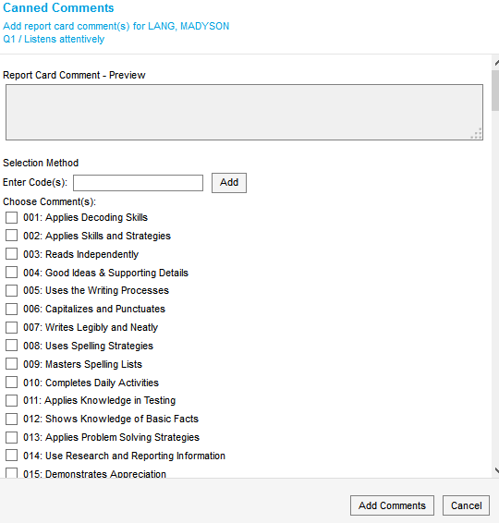
Help
If you are looking for a print out of the 195 Canned Comments, on your desktop, click on the Helpdesk icon. When the helpdesk website pops up, in the “How can we help you today? box, type in Numbered Comments. Click on the link that pops up and download the document. At the bottom of the document, choose if you are elem, middle, or high school.

