WIRELESS ISSUE – Can’t connect to ELPA21 Website

This is how the wireless icon should look if it’s working correctly.

If a student attempts to logon to ELPA21 site and it won’t open, look at the wireless icon on the lower right hand corner of the desktop. If it has a yellow splat covering it go to Step 1.

Step 1 - The wireless light should be on and white.

If it’s yellow or not on press the Fn and F2 keys at the same time. If the light goes on proceed to Step 2. If it doesn’t go on or turn white set this laptop aside and get a different one.
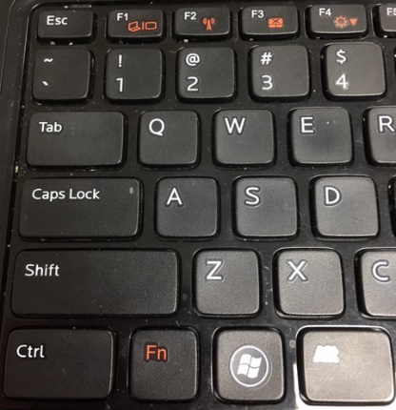

Step 2 – Click the wireless icon. Click SCSCHOOLS and click Connect. If that doesn’t work set this laptop aside and get a different one.

