NO SOUND RECORDING

- If the headphone won’t work, plug the headphone into a different USB port. It may take up to 10 minutes for the driver to install.
- If a student doesn’t have any sound after he or she records, right click the sound icon on the lower right hand corner of the desktop and choose “Recording devices”.

- Double click the microphone that has the green circle with the arrow.

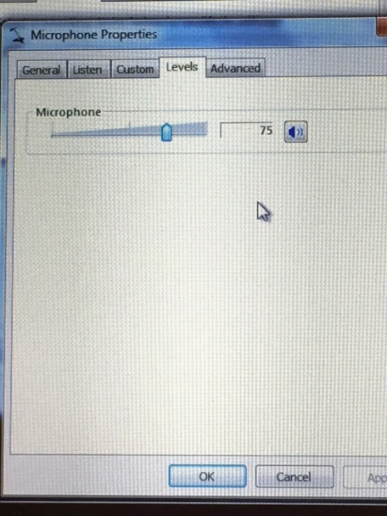
- Drag the sound line from 0 to 75 or higher. Click OK.

