How to Send School Newsletter to Parents via Email with Infinite Campus
Go to Messenger and then Message Builder.
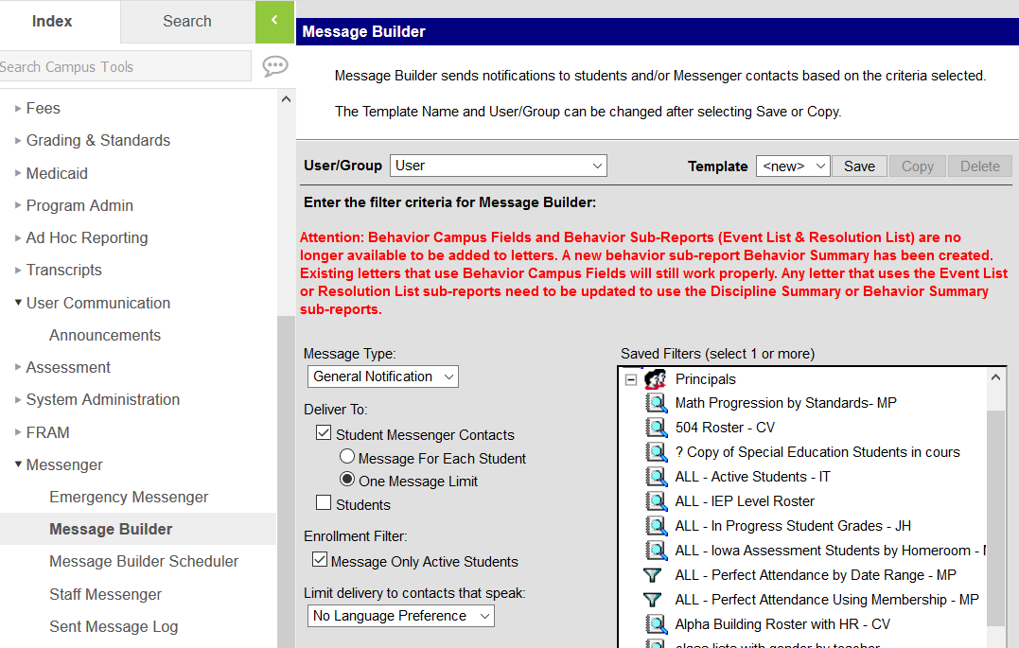
Select Message Type (almost all will be General Notification). Select Student Messenger Contacts. Select One Message Limit so families only receive one email. Check Message Only Active Students.
Under Saved Filters, go to Principals, and select Alpha Building Roster with HR – CV.
You may not see the Principals group below but you should see your groups. For example Registrar or Messenger Office
Type in your Message Subject and Message Body. Select Inbox to post the message to the Infinite Campus Parent Portal and Email to send a direct email to parent. The attachment WILL NOT go to the Infinite Campus Parent Portal. Include the following message in your email. Notice the sentence about not replying directly to the email since it is a generic email address.
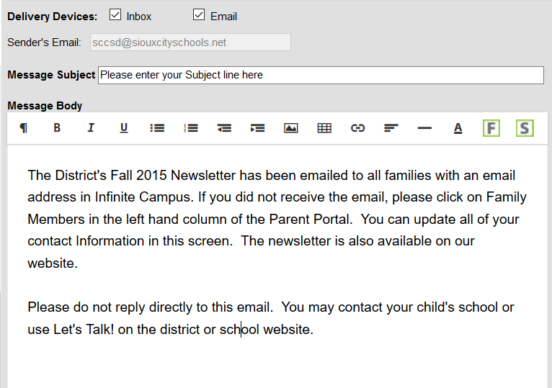
Attach your school newsletter by going to Browse and Upload. Send as a PDF document. When you are ready to send, Select Preview/Send.
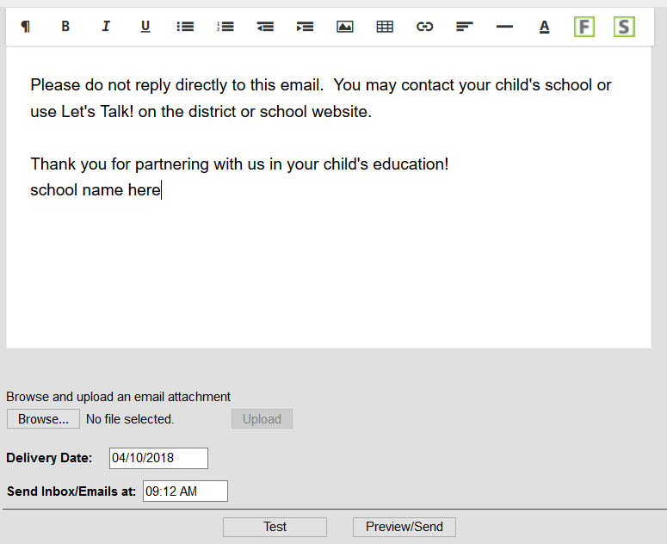

Click Send Message and you are finished.
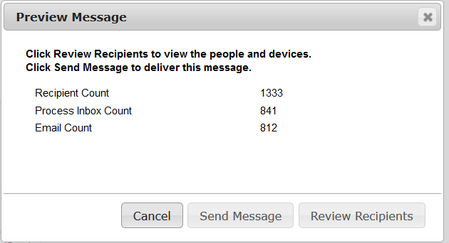
If you want to see who will receive the email or modify the list then click here.

