Snap and Read
What is it?
Snap & Read is the Next-Generation reading tool for Google Chrome, iPad and more, that can cover the most diverse reading needs. It reads both accessible and inaccessible text aloud, it levels vocabulary, and it translates, delivering usage data to teachers who then can more easily assess students’ reading needs individually.
Who can use it?
All middle and high school students and teachers.
How do they access it?
- Open Chrome
  - Copy the link below into your chrome browser and hit enter
https://chrome.google.com/webstore/search/snap%20and%20read%20universal
  - Click on add to chrome.
  - Click on add extension.
  - You are ready to use snap and read.
What do the students use to log in?
- Once you have added the extension to chrome, students will use their district email address and password to login.
- They will click on the snap and read icon on the top right of the browser/toolbar. 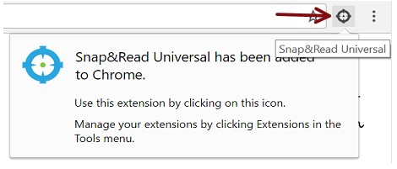
- Click on sign in,
- Sign in with Microsoft , not google.(Choose the work email option.)
- Click on or type in their email address and enter password.
- The extension is ready to use and can be used at any time in chrome.
- Here is a short video with an overview of the extension.
  - https://learningtools.donjohnston.com/product/snap-read/
- Here is a link that allows you to view videos on how to use the tool or to show to students.
  - https://learningtools.donjohnston.com/product/snap-read/
What if I do not have time to watch the video and learn how to use it?
We have coaches that will come around and work with you on it.
How long will it take to learn how to use it?
Usually about 5 minutes.
What if I want someone to come into my classroom and work with me on this extension?
Contact one of your coaches, general or special education and they will co-teach with you.

