Infinite Campus mobile app

Contents
Overview 2
Installing the mobile app 2
Using the mobile app 3
Assistance 5

Overview
You can access Infinite Campus from your phone with the mobile app to keep up with your student’s grades and attendance. Please note you must first successfully log into Infinite Campus via a web browser before you can use the mobile app.

Installing the mobile app

Using the app store on your mobile device search for “Infinite Campus” and download the free app. Students will select Campus Student and Parent/Guardians will use Campus Parent.

NOTE: You must have successfully logged into the Infinite Campus parent portal via a web browser before using the app for your smartphone.

See sample screen as shown:

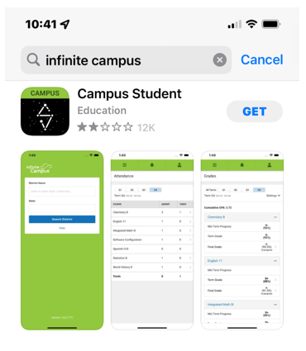
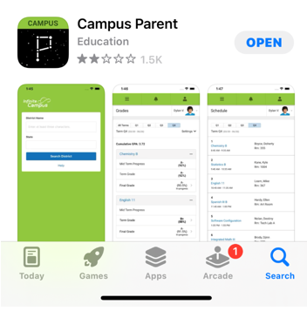

Using the mobile app
Step 1
In the District Name type “Sioux” and then click State and select “IOWA” from the list of states.
Then click Search District and select Sioux City Community School District from the list.

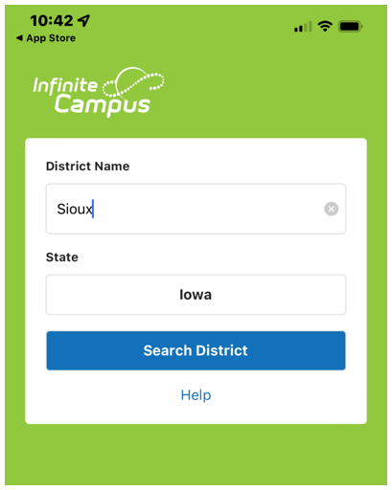

Step 2

Login using your parent portal login for Infinite Campus.

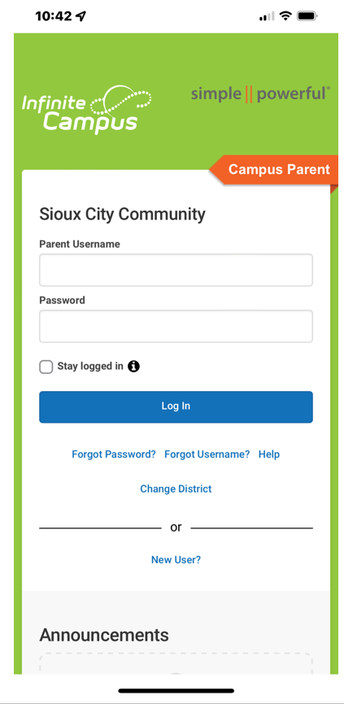

Assistance
If at any time you experience issues with your Infinite Campus mobile app, please enter a help desk ticket at this link or call the help desk at 712-279-6803.

