Setting up OneDrive for Business in Canvas
(a student must have setup OneDrive for Business already, click here for Setup directions)

Submit an Assignment
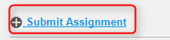
Open an Assignment and click Submit Assignment

OneDrive for Business tab
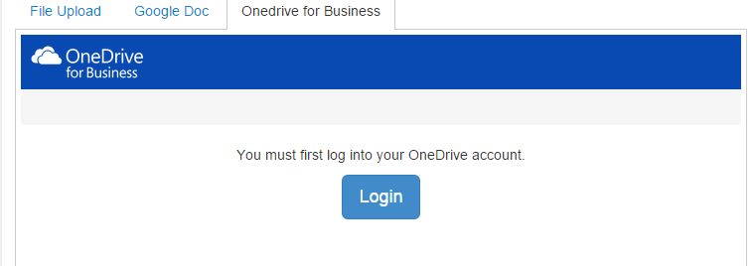
Click the OneDrive for Business tab and click Login

Login to OneDrive for Business
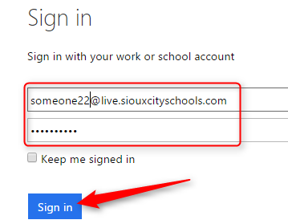
Login with your entire district email address and password, click Sign in
Accept Canvas permission
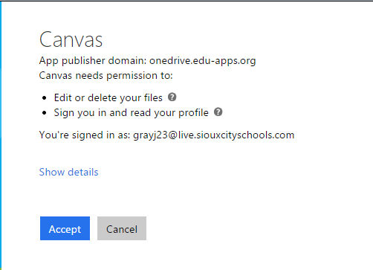
Click Accept

Troubleshooting

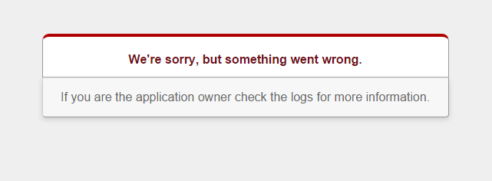
If you receive this error message, then close your browser and log back in.
If you continue to receive this error, then please contact Mike Crawford.

View OneDrive for Business documents
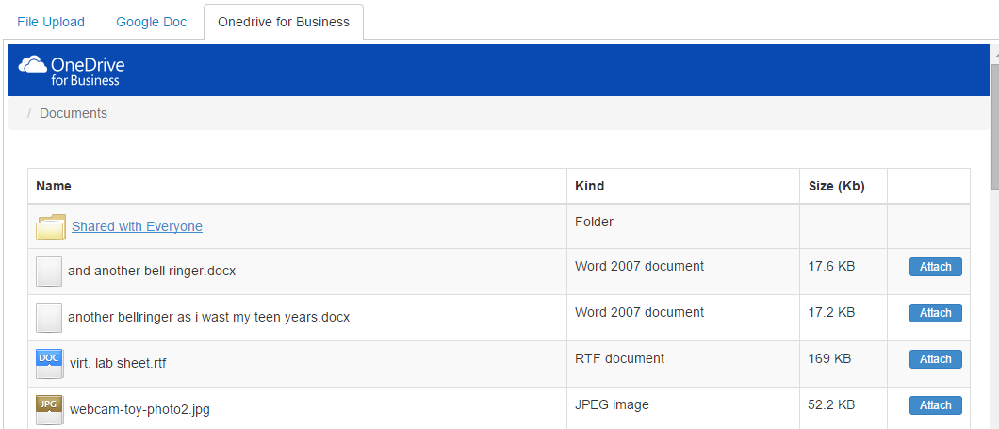
You should now see all of your files uploaded to your OneDrive documents folder. Select a file to submit by clicking the Attach button to the far right of the document name.

Submit Document
Verify the document name you want to submit for the assignment and click Submit Assignment

Submission confirmation
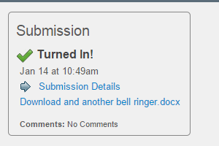
You will receive a confirmation of your submission in the upper right of Canvas.

