- Log in to infinite Campus using your district username and password. (Use Firefox)
https://campus.siouxcityschools.org/campus/siouxcity.jsp
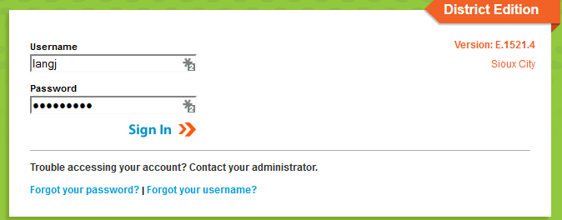

- Once you are logged in, make sure you are on the “gradebook side” of Infinite Campus. To make sure you are in the correct area, click the app switcher (9 little dots), and click Campus Instruction (Grade Book). Some of you already have your Grade Book set to automatically open on the Grade Book side, you are good to go.

- Along the left hand side of the screen, click Grade Book.
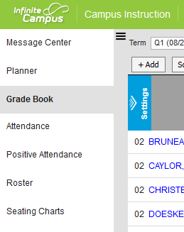

- Once you have clicked on Grade Book, on the top of the screen, in the section drop down, choose the section you want to add an assessment/assignment in. Then click add located right above the class roster.
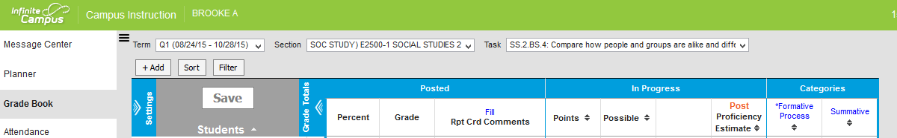
- Once you click Add, a new box pops up. Enter a Name for the assignment/assessment. Type in an abbreviation for the assignment as well. Where it says Due, click on the calendar and make sure the date you choose falls in the quarter you want the assessment/assessment to reflect on the report card. You do not need to change anything in GB Seq.
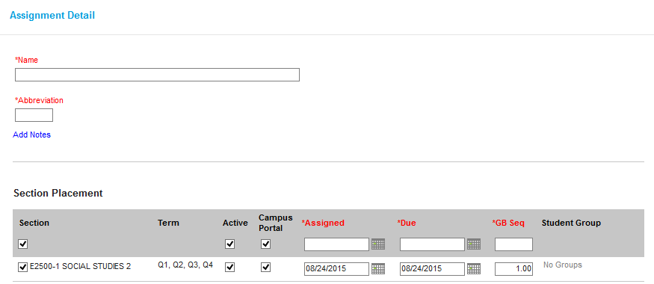
- Scroll down once you have set your assignment/assessment Due Date. In the Standards section, which Standards are being assessed either Summative or Formative Process?

- Click on the Standard(s) that are being assessed. (Might be a single standard, or may be multiple. Click all that apply) Click Summative or Formative Process depending on what you are adding to the Grade Book. Leave the Scoring Type to Rubric Click Save and Close
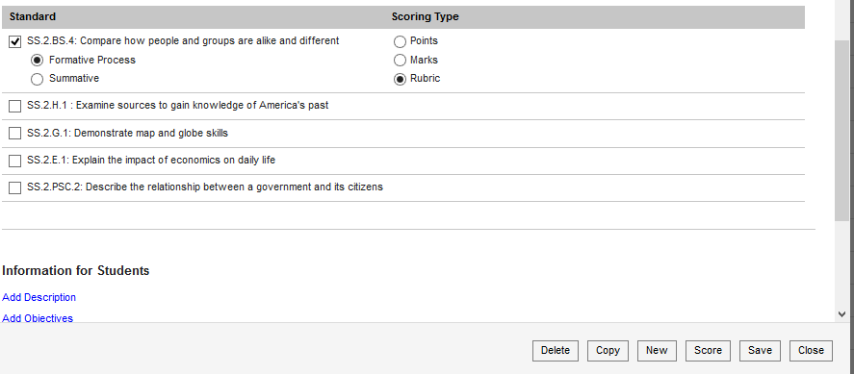

- Once you complete the previous step, you will now have a column in the Grade Book in which you can enter the Profiency Level (1-6)
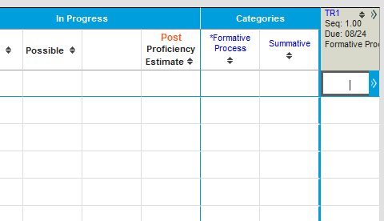

- In Infinite Campus, there are many ways you can enter scores. If you have a single standard, like shown in step 8, you can enter the 1-6 in the column like the picture above.
- If you have multiple standards, you can enter individual scores in the columns like above in each standard (task), or you can use multi score.
- To use multi score, click on the 2 little arrows that point to the right on the top of the Grade Book column you want to add scores in.
- Your Grade Book column will expand. On the right side, click Multi Score. A new box will open.
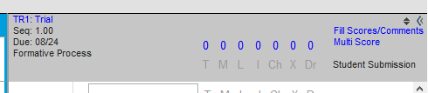
- In the multi score box, you will see student names across the left side and in the middle you will see the standards that you assessed and need scores entered. Once you have entered scores, Click Save
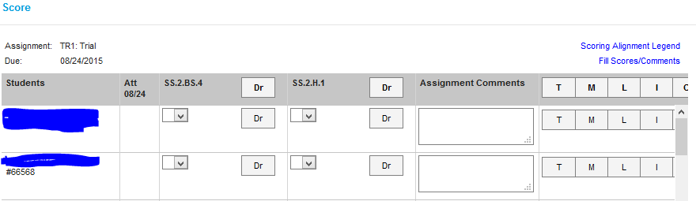
In Infinite Campus, there are many ways to add/enter items in to your Grade Book. The 2 ways mentioned in these steps are a great start, but not the only way.

