**Web IEP Enhancement: View a Student’s Graphs All at Once**

The Web IEP program now has the capacity for a user to view all of a student's graphs at one time. Web IEP users who have the ability to view all the students in a building will see the "Building Graph List" option under the “Student List” option on the menu:

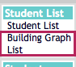

After selecting the "Building Graph List," the user will be able to choose the district, building and student to view:  
  
  
https://lh4.googleusercontent.com/ChZxWw8xnURPzyovdjAng1bw5qTyvu8BepH5hzTENR2mXLkH9krQCs6cnrujLQUI1dorIQSSLrDzGK6MXdfbOPbEhUB5f2xYiqzIBNeAVHfyU1Y6Gxv_EWH1u7puzvxkQXn6JQXj

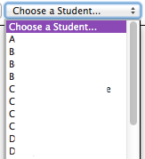

After choosing the student from the pull down list, the user will be able to view all the graphs for that student: