Moving Your Documents to Another Personal Device
(SD card, USB, Thumb Drive, Memory Stick, External Hard Drive, etc)

- Place your personal storage device into the correct port on the side of your computer (SD goes into SD slot, USB and others into USB port).
- Give your storage device a moment to configure or “talk” to your computer. Sometimes this takes 30 seconds to 2 minutes.
- Open your File Explorer.
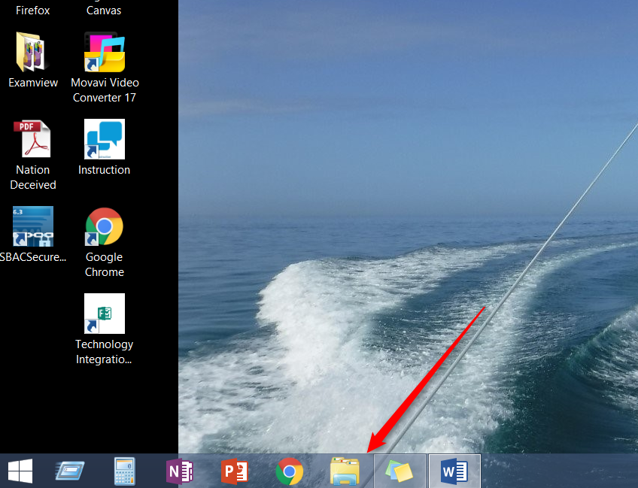
- Look for your files that are personal files. These could be in the Desktop, downloads, documents, music, photos, or videos files.
- Open those files one at a time. If you choose to move several files at once, I suggest maybe 10 at a time. If you are moving video files or extremely large files (like a whole book or a large folder of pictures), then do one at a time.
- Place your cursor over the file you want to move. Right click and then click cut.
- Move your cursor to your personal storage device and right click and then click paste.
- Click on your personal device to make sure your file is there.

