Instructions for Teachers and Students to Find their Applications
The Sioux City Community School District is attempting to simplify access to applications for teachers, students and staff. Change is not always easy and we ask that you bear with us. Our objective is that in the long run we make your and our jobs easier so you can focus on the students and not struggle with technology.

Quick Reference
For those of you who want to get going, here are brief instructions:
VERY IMPORTANT: PLEASE follow these instructions, even if you think you know how to get into your application or content. If you do not follow these instructions, you may have difficulty getting into some applications, such as LEXIA, iReady (which REQUIRE going through the Clever button!) and more!
- Teachers
  - Go to http://staff.siouxcityschools.org
  - Click on the Teachers banner which will display different applications or companies
  - Look for your application and if found, click on it. (NOTE: you may need to click on the up/down arrow to display sub options for an application or company)
  - If you do not see your application listed, choose the Clever button, log into Clever, using district username (not email address) and password, and look for the application there.
  - If you are not able to find your application, please enter a ticket into the help desk so we can help you find it.
- Students
  - Go to http://student.siouxcityschools.org
  - Click on the appropriate school level (elementary, middle or high school)
  - Look for your application and if found, click on it.
  - If you do not see the application listed, choose the Clever button, log into Clever, using district username (not email address) and password, and find the application there.
  - If you are not able to find the application, please enter a ticket into the help desk so we can help you find it.

More Detailed Instructions

Teachers
- Go to http://staff.siouxcityschools.org. Always start here!!!
- Click on the Teachers banner
- The screen should look like:
- 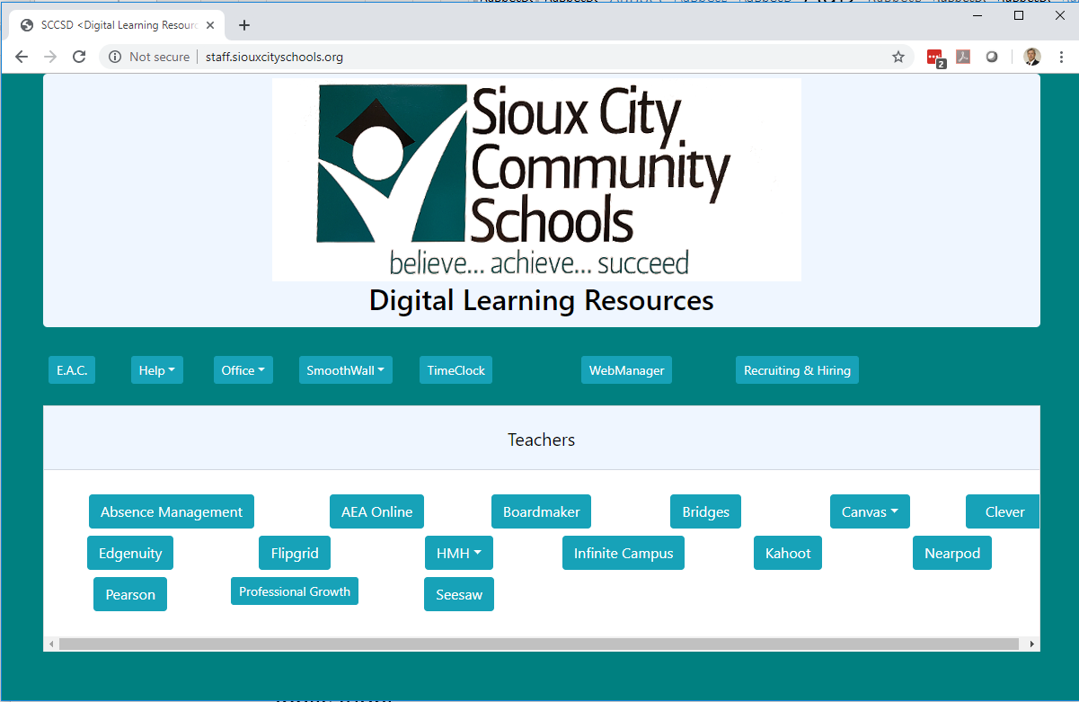
- Look for your application and if found, click on it. (NOTE: you may need to click on the up/down arrow to display sub options for an application or company)
- If you do NOT see the application, there is a button labeled “Clever” – Click on that. You will see a screen like the following:
- 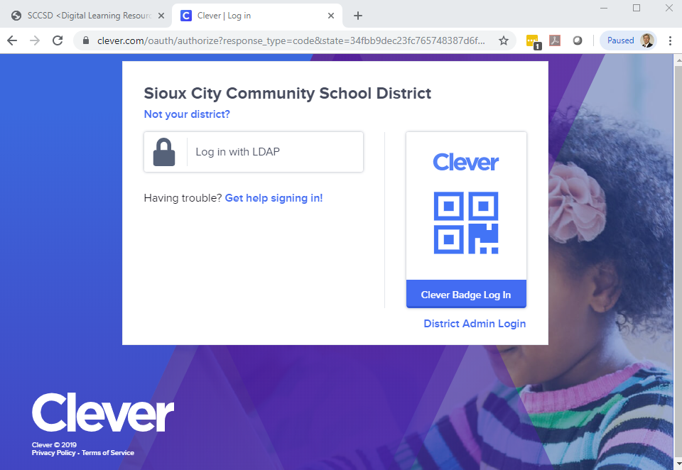
- Click on the “Login with LDAP” and enter your username (not email… just username – for example, “pritchj”, not pritchj@live.siouxcityschools.com) and password and the button Login.
- Once in Clever, you will see your Clever Homepage. Look through the homepage and look for the application you are attempting to use and click on it. Each application works a bit differently, but you should be taken into your application without having to enter your username and password again… and if the product is ‘rostered’ you should see your classes to choose from.
- 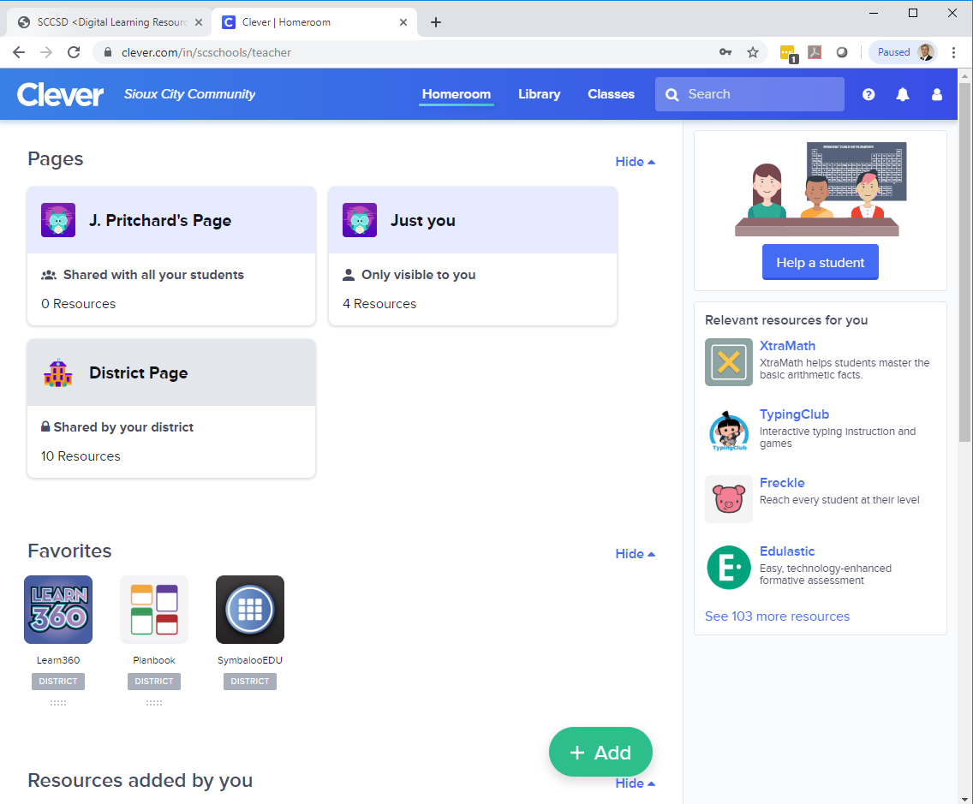
- There are a lot of features that we can make use of with Clever and your Clever Home Page and we plan on providing hints and training throughout the year to take advantage of those features.

Help!
If you need help, please enter a ticket into our helpdesk. You can get to the helpdesk by clicking on the icon on your desktop that looks like
Or you can go to the website:
http://sccsd.freshdesk.com/support/home

Students

- Go to http://student.siouxcityschools.org. Always start here!!! The screen should look like:
- 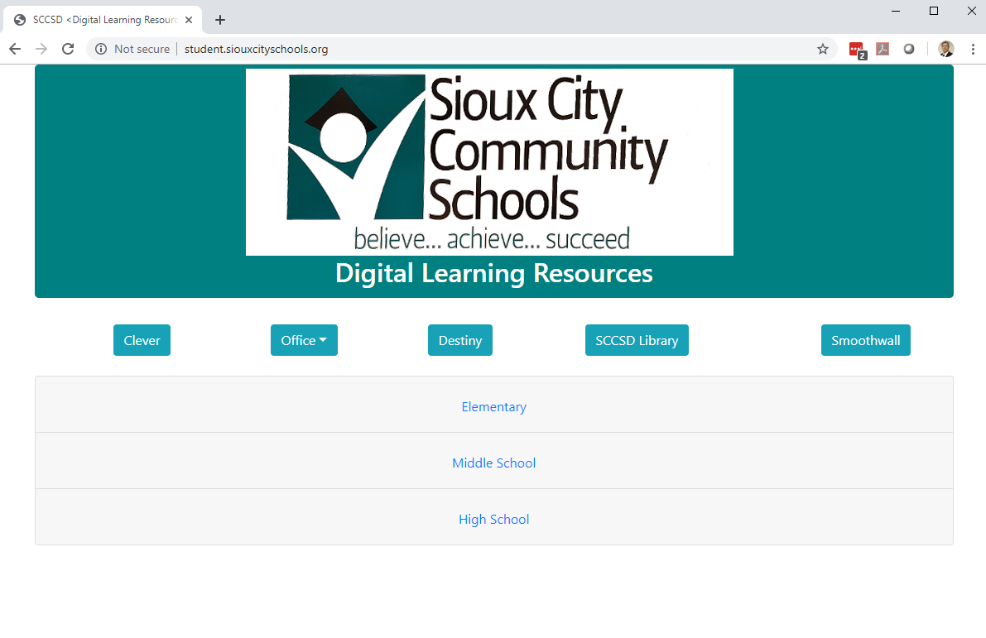
- Click on the appropriate level of building (Elementary, Middle, High). This will display a list of applications.
- 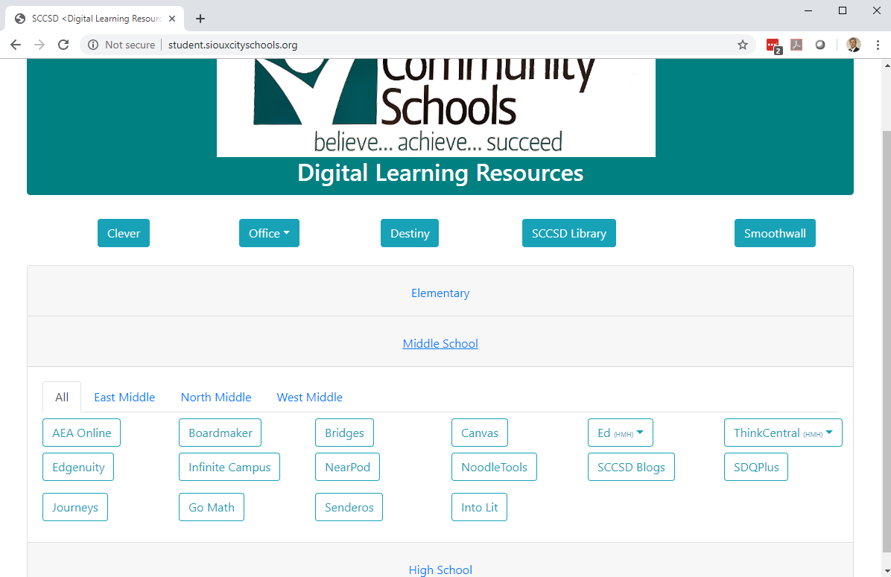
- If you see the application you are looking for, click on it and you should be taken to that application. Depending on the application, you may (or may not) be asked to ‘log in’ and you may or may not see your classes and roster of students.
- If you do NOT see the application, there is a button labeled “Clever” (top row, blue buttons) – Click on that. You will see a screen like the following:
- Click on the “Login with LDAP” and enter your username (not email… just username – for example, “pritchj”, not pritchj@live.siouxcityschools.com) and password and the button Login.
  - NOTE: Younger students may have a clever badge. They will click on the Clever Badge Log In, Allow the Camera, and display your badge. Please see your building Consulting Teacher for more information on badges!
- Once in Clever, you will see your Clever Homepage. Look through the homepage and look for the application you are attempting to use and click on it. Each application works a bit differently, but you should be taken into your application without having to enter your username and password again… and if the product is ‘rostered’ you should see your classes to choose from.
- 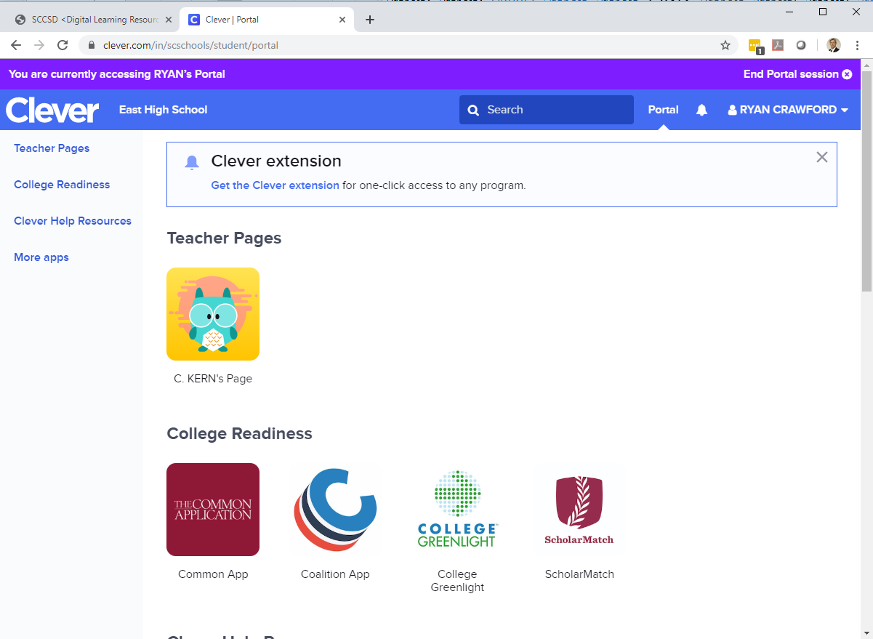
- Remember to page down to look at all the icons for your application. If you cannot find your application, please submit a help desk ticket

Help!
If you need help, please enter a ticket into our helpdesk. You can get to the helpdesk by clicking on the icon on your desktop that looks like
Or you can go to the website:
http://sccsd.freshdesk.com/support/home

