Co-Writer
What is it?
Co-writer Universal (for Google Chrome) uses grammar and vocabulary-smart word prediction, translation support, and speech recognition to help unstick ideas and get them to flow in writing.
Who can use it?
All middle and high school students and teachers.
How do they access it?
- Open Chrome
  - Copy the link below into your chrome browser and hit enter
  - https://chrome.google.com/webstore/detail/cowriter-universal-extens/ifajfiofeifbbhbionejdliodenmecna
  - Click on add to chrome.
  - Click on add extension.
  - You are ready to use co-writer.
What do the students use to log in?
- Once you have added the extension to chrome, students will use their district email address and password to login.
- They will click on the snap and read icon on the top right of the browser/toolbar. 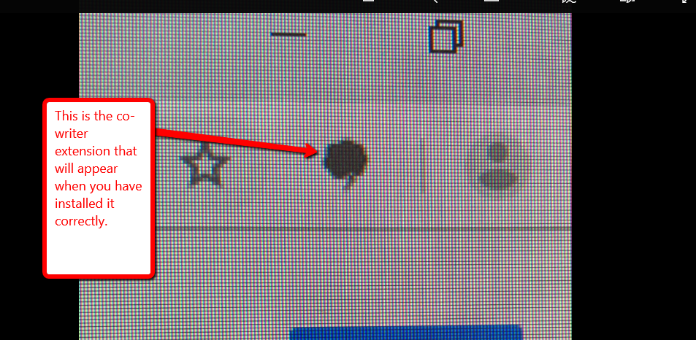
- Click on sign in, It may ask you or prompt you to sync, DO NOT SYNC.
- Sign in with Microsoft , not google.(Choose the work email option.)
- Click on or type in their email address and enter password.
- The extension is ready to use and can be used at any time in chrome.
- Here is a short video with an overview of the extension. https://learningtools.donjohnston.com/product/cowriter/
What if I do not have time to watch the video and learn how to use it?
We have coaches that will come around and work with you on it.
How long will it take to learn how to use it?
Usually about 5 minutes.
What if I want someone to come into my classroom and work with me on this extension?
Contact one of your coaches, general or special education and they will work with you and/or model the use with you.
What students are able to use co-writer?
All secondary students have accounts.
What student population will benefit from the use of co-writer?
All students will benefit, but it is extremely helpful with students that struggle in the area of writing.

